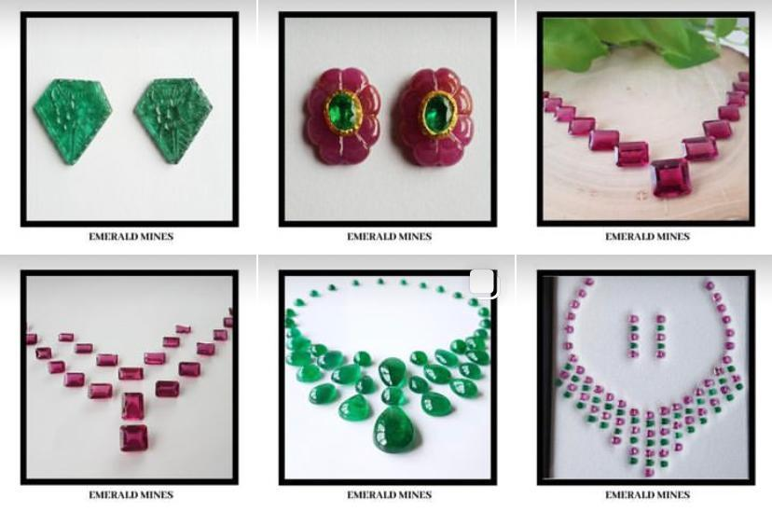

**ABOUT US**

Emerald Mines was founded under the guidance of **Mr. Anil Tambi** in the year 1980 in Bangkok, Thailand. We are dealers of Emerald, Ruby & Sapphire and Semi Precious stones specialising in layouts, cuts, cabochon & carvings in all shapes and sizes.

We are distinguished dealers of natural stones including Emeralds, Rubies, and Sapphires. With over four decades of experience, we have honed our skills and expertise to offer the finest quality gemstones to our clients worldwide.

Our active participation in global gemstone exhibitions underscores our commitment to showcasing the finest gemstones to an international audience. Our presence at these events not only highlights our products but also reinforces our position as a leader in the industry.

**SPECIALITIES**

* Layouts: Expertly crafted layouts to highlight the natural beauty of each stone.
* Cuts: Precision cuts that enhance the brilliance and fire of the gemstones.
* Cabochon Carvings: Intricate cabochon carvings showcasing the unique characteristics of each gem.
* Calibration: Accurate calibration in all sizes and shapes, including oval, octagon, pear, cushion, and mix.

**MEMBERSHIPS**

* International Coloured Gemstone Association (ICA)
* Gem & Jewellery Export Promotion Council (GJEPC)
* All India Gems & Jewellery Trade Federation (GJF)

Explore our collection and discover

the timeless beauty of our

Natural Stones.

Emerald Mines è stata fondata nel 1980 a Bangkok, Thailandia. Siamo commercianti di smeraldi, rubini, zaffiri e pietre semipreziose specializzati in layout, tagli, cabochon e intagli in tutte le forme e dimensioni.

La nostra partecipazione attiva alle esposizioni globali di pietre preziose sottolinea il nostro impegno nel presentare le pietre preziose più pregiate a un pubblico internazionale. La nostra presenza a questi eventi non solo mette in risalto i nostri prodotti, ma rafforza anche la nostra posizione di leader nel settore.