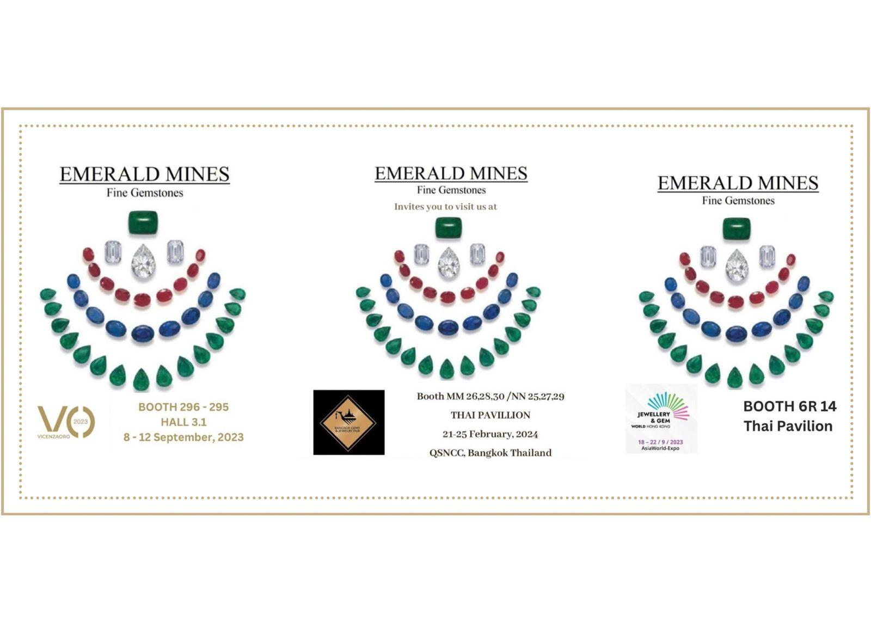

**TRADE SHOW PARTICIPATION**

We actively participate in various gem and jewellery shows throughout the year, ensuring we stay at the forefront of industry trends and innovations.

UPCOMING EXHIBITIONS, 2025

| **EXHIBITION NAME** | **DATE** | **MONTH** | **BOOTH NUMBER** |
| --- | --- | --- | --- |
| VICENZAORO, ITALY | 4-9 | SEPTEMBER | HALL 3.1, BOOTH 272-273 |
| 72ND BGJF, BANGKOK, THAILAND | 9-13 | SEPTEMBER | NN 26, 28, 30 / PP 25, 27, 29 |
| JGW, HONGKONG | 15-19 | SEPTEMBER | 6R14, AWE |
| JGT DUBAI | 11-13 | NOVEMBER | SH 14 |

PAST EXHIBITIONS, 2024

| **EXHIBITION NAME** | **DATE** | **MONTH** | **BOOTH NUMBER** |
| --- | --- | --- | --- |
| JAS JAIPUR | 5-7 | JULY | 95 |
| VICENZAORO, ITALY | 6-10 | SEPTEMBER | HALL 3.1, BOOTH 272-273 |
| 70TH BGJF, BANGKOK, THAILAND | 9-13 | SEPTEMBER | MM26,28,30/ NN25,27,29 |
| JGW, HONGKONG | 16-20 | SEPTEMBER | 6R14, AWE |
| JGT DUBAI | 12-14 | NOVEMBER | SH 14 |